
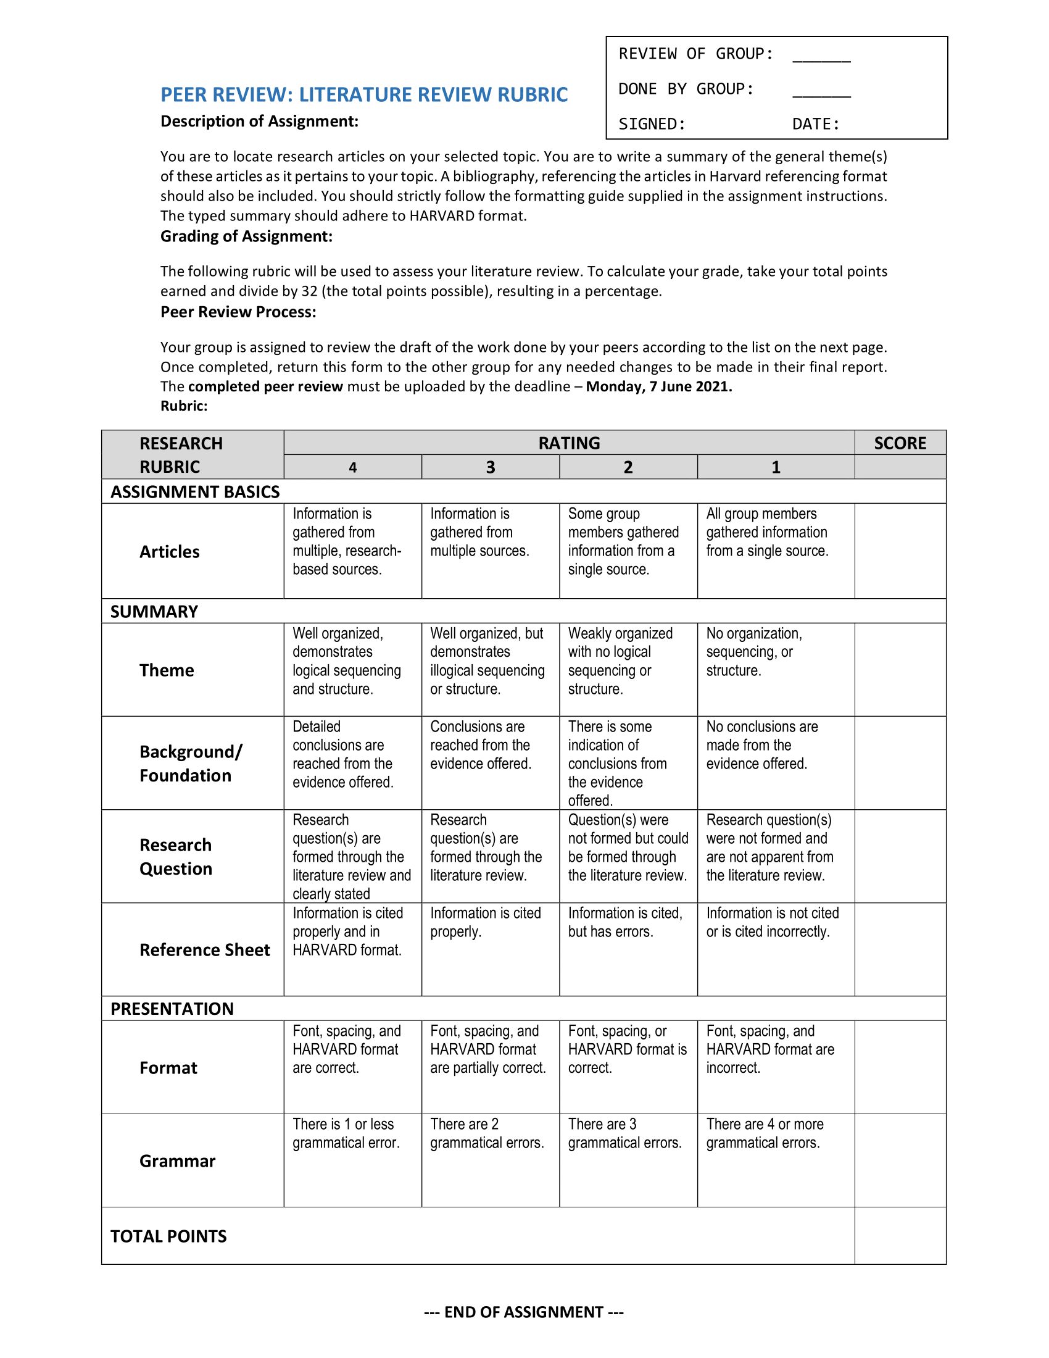
Title: Traditional and Agile Project Management in Practice.
Subtitle: A Comparison Between Agile and Traditional Project Management.
Question: What are the critical factors that influence the success of projects implementing agile versus traditional methodology?

7/6/2021
30
Table of Contents
Introduction 3
Literature Review 4
Broad view 4
Narrowed Down View 7
Findings 14
Conclusion 16
Bibliography 17

Introduction
Since the adoption of computers in the business market took place software development experienced a huge increase in demand. However, there was a huge problem: the time it took for an application to be developed in comparison to when the application was needed was far too great. It was even known as “The Applications Development Crisis” (Varhol, 2021). This lag in the development of an application needed to be addressed and this was one of the main reasons for the creation of the Agile Development framework. Today, this framework is not only used in applications development, but has spread to many other sectors for its efficiency in projects that experience many changes throughout their lifespan.
We are specifically interested in the critical factors that influence the success of projects that chose to implement the agile methodology over the traditional methodology. To investigate this further we have reviewed existing literature covering agile project management. After doing so, we related what we found in these articles to our specific interest and thereafter we analysed whether the existing literature adequately covers our interest within agile project management.
We will be reporting on the success factors of agile and traditional project management. Other project management methods are not the focus of our research. Furthermore, the priority will be upon agile project management opposed to traditional project management.

Literature Review
Broad view
The purpose of our literature review is to illustrate our research of what others have discovered based on agile project management.
According to this article, agile project management is a people focused process which takes in to account the development team’s members’ abilities. It is important that development teams are both autonomous and diverse when using agile project management strategies.
There are many agile methodologies, most of which promote unit testing after each run of development is complete. Agile strategies are developed collaboratively, and users can interact with the product during development. This allows developers to get feedback very quickly so that they can build solutions better fitted to the demand. Agile development is a very rapid process, each cycle is usually measured in days or even hours.
There are concerns around how well agile methods can scale from small projects to huge projects. Agile utilizes each individual team member and their skills over tools and processes making it difficult to use in large projects. (Thota, H., 2010, pp.7-8.)

This article further demonstrates the above by comparing agile development and plan driven development co-existing in business environment. It demystifies the concepts or getting a product faster to market while not knowing the labour involved behind the product and the challenges faced. It looks at two Netherlands based IT companies with a hybrid agile approach, and it found that there is an imbalance between the personnel involved. The authors raise attention at the complexity of an organization’s IT landscape as they are merged and integrated together, in every way possible which can derail the business processes and create imbalances in the human resources required. The nearing of deliverables and objectives to be completed increases the rate of productivity which has an adverse effect, as noted by a business analyst of one of the companies surveyed. Poorly planned agile integration has consequences and constraints when used in large scale.
It is easy to lose track of priorities within a complex enterprise environment where the development of different parts of a system is dispersed over multiple teams and/or concurrent projects. (van Waardenburg, G. and van Vliet, H., 2013, pp.2154-2171.)

However, these authors, Daniel J Fernandez, and John D Fernandez, encourage professionals to implement agile project management into the workforce since its flexible in a project system and can adjust to the emerging challenges and opportunities that arise from time to time. In a hierarchical approach which is the traditional project management approach it is almost impossible to keep up with the standards that the agile project management approach offers as change occurs within the project. (Fernandez, D. and Fernandez, J., 2021, pp.10-17.)

Authors Michael Karlesky and Mark Vander Voord state that traditional project management aims to prevent or limit changes beforehand by thoroughly planning and documenting the aspects of the project en route, since change is one of the most expensive aspects of software development. On the other hand, agile project management sees the above as (planning and documenting) a waste of time and rather focus on delivering a working product, since project failure is seen as the most expensive aspect of software development. Doing things this way shows that change is something manageable for the agile project management. (Karlesky, M. and Vandervoord, M., 2018)

Similarly, the author of this text, Mahanti A, agrees that the traditional project management approach reports on analysis, design, and delay problems in the early stages of a project while agile methods execute the disciplines in short bursts iteratively, it proves to be worthwhile for the sponsor as they can see the progress.
The article covers many advantages of agile such as improved control over a project and reduced dependency on individuals along with increased flexibility due to working in teams. While the article is generally upbeat about agile practices, it does mention that introducing these methods can be a difficult task.
In terms of productivity and cost, according to Mahanti and Reifer, agile enterprises have seen 15-23% gain in productivity, 5-7 % reduction in costs, 25-50% reduction in time-to-market.
The study finds that there are common challenges enterprises face when adopting Agile Methods such as IT professionals being accustomed to serial approaches being resistant to change. Believing that Agile will lead to discourse and disrupt the traditional project development hierarchy.
A documentation-heavy mindset is also a challenge as managers focus on producing comprehensive, detailed requirements and design documents over quality software. Instead of focusing on focus on code development over creating UML design artifacts. Specialized skills for teams are also mentioned as being a scarcity which leads to imprecise and low-quality software.
Large enterprises have a primary challenge of integrating the agile practices into already existing processes. There is a universal agreement that there is no one-size-fits-all methodology, as companies have different projects and programs to cover.
Lastly, there are limitations to applying agile software processes in enterprise such as limited support for large development groups as agile processes fair well with small collaborations and teams. (Mahanti, A., 2006, p.197.)

In addition to that, M.A. Awad’s findings state that agile methodologies can be seen to be beneficial for small scaled and medium scaled projects, but traditional methods dominant large, scaled projects. They also known as traditional methods as heavyweight and agile methods as lightweight. (Awad, M., 2019)

Narrowed Down View
From the above-mentioned findings, we have found a gap of knowledge which led to us investigating the critical factors that influence the success of projects implementing agile versus traditional methodology.
According to T Rattan, one should keep in mind that not all projects are suited to a traditional or agile approach. Therefore, it is important to choose the right project methodology to ensure successful completion of the project. The crucial factors that guide individuals working in projects is to choose the right project management approach for a project by conducting an assessment factor for choosing a project methodology. The assessment factors look at the involvement of top management, the structure, culture, communication and how trained the workforce is in an organisation. These factors along with the project planning attributes dictate to the methodology.
The project planning attributes are scale, budget, risk-management, the managerial and implementational models. (Rattan, T., 2013)

Furthermore, Elena Zavyalova, Dmitri Sokolov and Antonina Lisovskaya found that traditional project management uses diverse human resource management architectures. While some companies would benefit from using agile approaches, a company should evaluate their project management approach and compare it to their human resource management architecture, this will determine whether an agile or traditional approach suits the company best. (Zavyalova, E., Sokolov, D. and Lisovskaya, A. (2020), pp. 1095-1112)
Looking At Traditional Project Management
Authors Jovanovic, P and Beric found that traditional methodologies have a strict and accurate plan of action, based on the description of that project structure before its initial implementation and it is presented in a project documentation. The success of traditional project management is that the traditional methodologies govern their practise by considering clearly defined project execution technology, having a solid project structure, acknowledging possible change, incorporate multifunctional team and allowing the project manager to have high authority, just to name a few. These factors contribute to the success of the traditional project management. (Jovanovic, P., & Beric, I., 2018, p1-13)

Hanadi Salameh found in her research that traditional project management methodologies are more successful when the project’s requirements are unlikely to change, where the scope of the project is large or where there is known to be enough time to complete the project fully. (Salameh, Hanadi, 2014)

Stoica, Mircea and Ghilic-Micu state that for the success of a traditionally managed project, documentation of the project’s entire life cycle (cost, time, resources) is key as it will act as a reference as the development team code during that period. This will allow the development team to focus more on their tasks and be productive rather than having to explain their work to other team members. Here all objectives should be stated clear before the start of the project and any changes will be managed through a strict manner and prioritized. The timeframe will guide the development team on their deliverables due to contribute to the completion of the project.
Traditional project management is suited for large projects but will still be effective with small and medium projects. (Stoica, M., Mircea, M. & Ghilic-Micu, B., 2013, pp. 64-76.)
The authors Naoum, Fong and Walker investigate the factors that influence success or failure in project management. The authors identify a project as having different subsets.
The first is made up of the project goal, scope, criteria or requirements and work definition, the initial phases of in project development.
The second consists of the organisational structure, project team and manager. The three factors form a structure that is crucial to how the different groups of people work together.
The third subset includes the planning and programming techniques, cost estimate and control. At this level, the scope should be defined. The workforce, cost and budget are allocated.
Lastly, the standard measures and procedure are planned and prepared. The fourth subset is based on the dynamics between the project manager and project team. It is focused on the overall management and development of the project. (Naoum, SG, Fong, D and Walker, G, 2004)

Adam Collins and David Baccarini say that there are two different project success criteria views for traditional project management, which is where project success is only seen in terms of objectives of time, cost, and quality. On the other hand, project success is considered as the efficacy of the project’s product meeting the client’s needs. Accomplishing either one or both above contributes to the success factors of traditional project management.
Because project requirements in software engineering are not always known from the start and often change, the factors that make traditional project management strategies successful often are not there. But the same could be said for agile, where the client may not have the time to meet with the development team every week to review what they have produced. Often, agile methodologies have a higher chance of success when developing software, but that depends on the specific circumstances of each project which factors into the success of the method used. (Collins, Adam & Baccarini, David., 2004, p211-231)

LOOKING AT AGILE PROJECT MANAGEMENT
Authors Boehm and Turner state that there are important factors that lead up to successful implementation of agile methods but denote that there are risks involved, only mitigated when tools and techniques involved in the environment are aligned to adopt this method.
Factors that assist in successful implantation of agile approaches within an organization include, availability to dedicated business expertise, tools, and techniques as available to members, agile teams should be measured by overall value and added creation lastly, smaller teams usually succeed in agile settings and members should be allocated to a singular project. Success factors of a project are measured against dimensions which represent the environment and resources used in a project such as, Organizational structure, Human resource, processes, technical and project artefact. (Boehm, B. and Turner, R., 2005, pp.30-39.)

According to Harry Henderson, traditionally, projects were developed by first creating a complete plan agreed on by both the developers and the clients and then building the software according to that plan. There are many problems with the traditional way software is developed, information that was not thought of during the initial plan creation could have been left out and specific details may not have been explained well enough for the developers to fully understand what they need to create.
To correct these overlooked or omitted items, the developer team needs to have another meeting with the clients which, in a lot of cases, costs time, of which neither the client nor the developer have set aside for this and can also cost a lot of money.
Customers needed working software quicker and sometimes discovered new requirements that were not anticipated. Agile strategies are a response to these new needs. The agile approach delivers working software a lot sooner that the traditional method as well as going through continuous testing and gathering feedback, so the client gets everything they need. (Henderson, H., 2017)

Elena Zavyalova, Dmitri Sokolov and Antonina Lisovskaya say that traditional project management uses diverse human resource management architectures. While some companies would benefit from using agile approaches, a company should evaluate their project management approach and compare it to their human resource management architecture, this will determine whether an agile or traditional approach suits the company best. (Zavyalova, E., Sokolov, D. and Lisovskaya, A., 2020, pp. 1095-1112)

In summary, some experts think the critical flaws of traditional project management are the key attributes that distinguish it from agile. Some researchers above mentioned that where its strengths are is that traditional project management is structured, well-organized, and emphasizes on pre-planning. Traditional project management approaches a project holistically, by planning tasks well ahead and carrying them out sequentially. Traditional project management’s structured nature makes it more reliable and methodical. However, research shows that the nature of traditional project management and that of projects, are direct opposites. Projects are dynamic and prone to changes, whereas traditional project management is static, and resistant to changing conditions. The key factors of traditional project management make it incapable of resolving emerging problems. Instead, the adopting of traditional project management increases pitfalls in a project while agile project management can capitalize on such pitfalls due to its flexibility within projects. Although agile project management can be very effective in many instances, this is dependant on the project manager understanding the agile framework. The rewards of agile management cannot be obtained if the project manager does not have this understanding.

Findings
Agile project management is an iterative way of conveying a project for the duration of its life cycle. There are multiple gradual steps in an agile life cycle towards completing a task. Iterative methodologies are as often as possible utilized in software development to advance speed and versatility since the advantage of iteration is that you can change as you come as opposed to following a direct way. One of the points of a coordinated or iterative methodology is to deliver benefits all through the cycle instead of just toward the end. At the center, agile projects should display focal qualities and practices of trust, adaptability, strengthening, and coordinated effort.
Traditional project management on the other hand, is a widespread practice that incorporates a set of created strategies utilized for arranging, assessing, and controlling exercises. The point of those strategies is to arrive at the ideal outcome on schedule, inside spending plan, and as per requirements. Traditional project management is mostly utilized on projects where activities are finished in a fixed order and there are infrequently changes to be made.
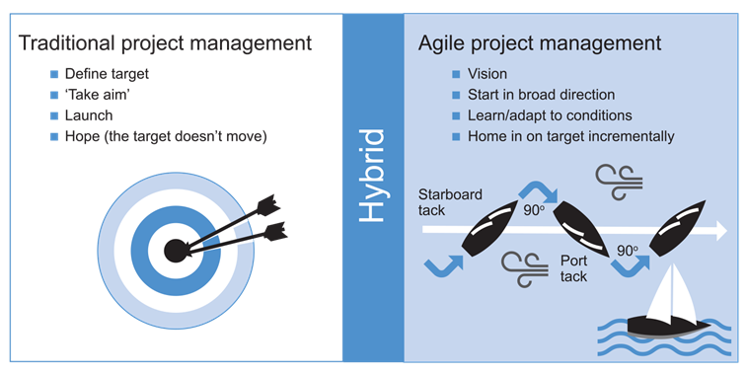
Source: APM-Directing Agile Change
Agile is characterized by both a broad range of techniques and methodologies and a wide array of principles and values that it shares. There are distinct advantages and disadvantages to each of them. The most popular agile frameworks are Scrum and Kanban.
Product development projects that are innovative and complex usually require the use of Scrum. However, nothing is perfect, and drawbacks are inevitable. Adopting the Scrum framework into large projects can be challenging. Only experienced team members can ensure the success of the framework and if one of them leave whilst the project is on the way, it can have a huge negative effect on the project. This does not mean we should frown upon the Scrum framework. Project deliverables can be completed faster and more efficiently with Scrum. Daily scrum meetings also allow each team member to express their individual efforts.

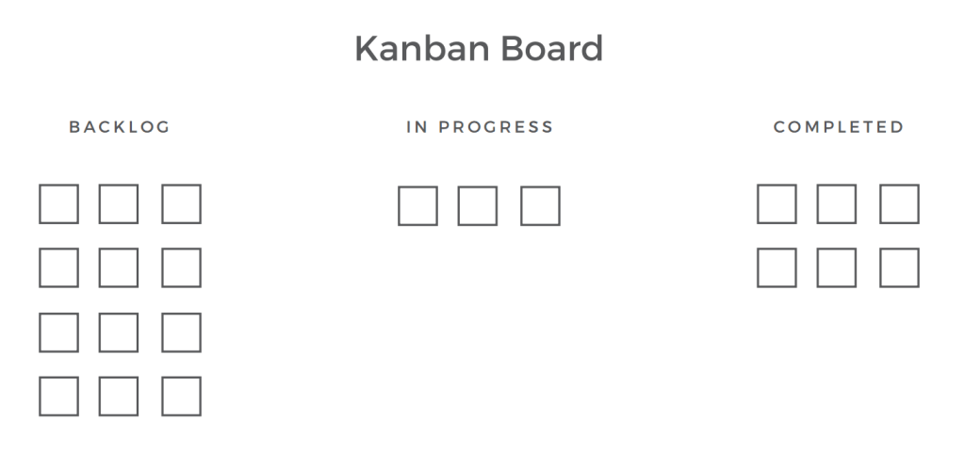
Kanban is a highly efficient method of managing software development processes. Compared to Scrum, Kanban is a methodology that is less structured. Processes are not outlined in this methodology. As a model, it introduces a method to improve a process incrementally. There is no specific role prescribed by Kanban. Whenever there is capacity, new items can be added to the board. However, as mentioned before, drawbacks are inevitable. There is no timing associated with each phase, so the process is prone to delays. Ultimately, the development process can be affected by an outdated Kanban board.
Source: Altexsoft -Kanban

As part of an agile project, multiple solutions are developed iteratively for a problem. Therefore, it is typical for large agile projects to include multiple scrum teams. Not only do these teams depend on each other, but they also work together. Therefore, coordination among the teams is essential to avoid any gaps in agile methodology. If this continues, the project may fail or grow out of control. Similarly, a project utilizing agile methods usually has a leader who always must be on his or her toes. The team can be stubborn and wary of frequent changes, making it difficult to adopt the deliverables. Even simple daily scrum calls can be too much for them. Therefore, establishing his role as a supportive leader and generating trust towards him becomes a daunting task.
With the increased competition among organizations, Agile management has become a preferred management method since it allows a company to adapt to changing circumstances. It allows not only for dealing with change, but also for creating and generating change (Highsmith 2002). With agile project management, organizations can develop innovative products through frequent communication, involvement by users, frequent releases, and responsiveness to change (Surendra 2009).
There have been significant gains in the adoption of agile management in other industries such as the financial services sector by 15%, coaching by 10%, education by 5%, as well as other fields including entertainment by 5%. Considering the challenges faced by the organizations, it appears they looked to adopt agile management to introduce innovation in their projects.

Conclusion
Agile project management is a more effective way to manage a project wherein the outcome is not static, and the requirements can change over the project lifetime. This way of managing values client interactions, project adaptability and a functioning result over the traditional values placed on extensive planning and the documentation of processes. However, it is easy to lose track of priorities within a complex enterprise environment where the development of different parts of a system is dispersed over multiple teams and/or concurrent projects.
We found that there is a gap in the knowledge relating to our research question. There are plenty of articles analysing the success factors within traditionally managed projects, however the same cannot be said for projects managed through the agile framework. This information can be slowly acquired from other research about agile, but the number of articles that are solely based on these factors are extremely minimal. Considering this, we still managed to find enough information about the success factors of agile projects from existing research.
This area of agile projects should be further researched as it could greatly benefit those seeking to adopt the agile methodology, providing them with core areas that should be focussed on for a greater chance at project success.

Bibliography
- Varhol, P., 2021. The complete history of agile software development. [online] TechBeacon. Available at: <https://techbeacon.com/app-dev-testing/agility-beyond-history-legacy-agile-development> [Accessed 24 May 2021].
- Thota, H., 2010. Key concepts in innovation. Basingstoke: Palgrave Macmillan, pp.7-8.
- van Waardenburg, G. and van Vliet, H., 2013. When agile meets the enterprise. Information and Software Technology, 55(12), pp.2154-2171.
- Fernandez, D. and Fernandez, J., 2021. AGILISM VERSUS TRADITIONAL APPROACHES AGILE PROJECT MANAGEMENT, 49(2), pp.10-17.
- Karlesky, M. and Vandervoord, M. (no date) Agile Project Management (or Burning Your Gantt Charts). Available at: https://atomicobject.com/uploads/archive/files/EmbeddedAgilePMPresentation.pdf (Accessed: 28 March 2021).
- Mahanti, A., 2006. Challenges in Enterprise Adoption of Agile Methods - A Survey. Journal of Computing and Information Technology, 14(3), p.197.
- Awad, M. (no date) A Comparison between Agile and Traditional Software Development Methodologies. Available at: https://www.unf.edu/~broggio/cen6940/ComparisonAgileTraditional.pdf (Accessed: 31 October 2019)
- Rattan, T., 2013. MIS40670 – Factors behind adoption of project management methodology. [online] Tarun's Blog. Available at: <https://tarunrattan.com/2013/11/20/factors-impacting-adoption-of-project-management-methodology/> [Accessed 24 May 2021].
- Zavyalova, E., Sokolov, D. and Lisovskaya, A. (2020), "Agile vs traditional project management approaches: Comparing human resource management architectures", International Journal of Organizational Analysis, Vol. 28 No. 5, pp. 1095-1112. https://doi.org/10.1108/IJOA-08-2019-1857
- Jovanovic, P., & Beric, I. (2018). Analysis of the Available Project Management Methodologies. Management: Journal of Sustainable Business And Management Solutions In Emerging Economies, 23(3), 1-13. doi:10.7595/management.fon.2018.0027
- Salameh, Hanadi. (2014). What, When, Why, and How? A Comparison between Agile Project Management and Traditional Project Management Methods. International Journal of Management Reviews. Vol.2,.
- Stoica, M., Mircea, M. & Ghilic-Micu, B. 2013, "Software Development: Agile vs. Traditional", Informatica Economica, vol. 17, no. 4, pp. 64-76.
- Naoum, SG, Fong, D and Walker, G (2004). Critical success factors of project management. CIB W107 and TG23 International Symposium on Globalization and Construction. Bangkok, Thailand
- COLLINS, ADAM & Baccarini, David. (2004). Project success - A survey. Journal of Construction Research. 5. 211-231. 10.1142/S1609945104000152.
- Boehm, B. and Turner, R., 2005. Management Challenges to Implementing Agile Processes in Traditional Development Organizations. IEEE Software, 22(5), pp.30-39.
- Henderson, H. (2017). Agile software development. In H. Henderson, Facts on File science library: Encyclopedia of computer science and technology. (3rd ed.). [Online]. New York: Facts on File. Available from: http://libproxy.cput.ac.za/login?url=https://search.credoreference.com/content/entry/fofcomputer/agile_software_development/0?institutionId=3652 [Accessed 22 March 2021]
- Zavyalova, E., Sokolov, D. and Lisovskaya, A. (2020), "Agile vs traditional project management approaches: Comparing human resource management architectures", International Journal of Organizational Analysis, Vol. 28 No. 5, pp. 1095-1112. https://doi.org/10.1108/IJOA-08-2019-1857
- Ekanayake, H. and Idar, R., 2021. Traditional Project Management Approach, Industry Challenges and Key Attributes: A Case Study of Construction Project Management in Sri Lanka. Asia Pacific Journal of Advanced Business and Social Studies, 5(1), pp.52-64.
- AltexSoft. 2021. Agile Project Management: Best Practices and Methodologies. [online] Available at: <https://www.altexsoft.com/whitepapers/agile-project-management-best-practices-and-methodologies/> [Accessed 24 May 2021].
- Apm.org.uk. 2021. Agile project management. [online] Available at: <https://www.apm.org.uk/resources/find-a-resource/agile-project-management/> [Accessed 24 May 2021].
- Contenteratechspace.com. 2021. [online] Available at: <https://contenteratechspace.com/blogs/top-ten-challenges-of-agile-methodology/> [Accessed 24 May 2021].
- HRISTOVSKI, T., 2021. Agile methodologies: Kanban Vs Scrum – Advantages and Disadvantages – ⋮IWConnect. [online] Iwconnect.com. Available at: <https://iwconnect.com/agile-methodologies-scrum-vs-kanban-advantages-disadvantages> [Accessed 24 May 2021].
- Mrsic, M., 2021. Traditional Project Management · Activecollab Blog. [online] ActiveCollab. Available at: <https://activecollab.com/blog/project-management/traditional-project-management> [Accessed 24 May 2021].
- Simplilearn.com. 2021. Advantages and Disadvantages of Scrum. [online] Available at: <https://www.simplilearn.com/scrum-project-management-article> [Accessed 24 May 2021].
- Conrad, A., 2018. What Exactly Is Agile? A Definition of Agile Project Management. [online] Blog.capterra.com. Available at: <https://blog.capterra.com/definition-of-agile-project-management/> [Accessed 24 May 2021].

